GST No.: 09AAACU4749D2Z9 OFFICE OF THE CIN: U40101UP1980SGC005065
EXECUTIVE ENGINEER

CENTRAL PURCHASE DIVISION-I

PARICHHA THERMAL POWER PROJECT
UTTAR PRADESH RAJYA VIDYUT UTPADAN NIGAM LIMITED
(UPGOVT UNDERTAKING)
PO PARICHHA, JHANSI-284305
(UTTAR PRADESH) Fax: 0510-2782192
E-mail: eecpd12012@gmail.com

No. 1060/CPD-I/PTPP/O-1/CF442 Date: 11.10.2018
O&M, 2X250MW
Reg. no.487
Date 04.10.18
M/s Ashbond Engineers Private Limited,
B-9/3, Mainwali Nagar, Rohtak Road,
New Delhi-110087.

Sub: Order for Supply of “Iyappan” make Spares
Our Ref: Enquiry No: 442 /CPD-I/ PTPP/CF, dated 25.07.18.
Negotiation Letter No: 718/CPD-I/PTPP/CF442 dated 28.08.2018
Your Ref: Offer No: AEPL/Parichha/18-19/1355, dated 11.08.2018
And mail dated 30.08.18

Dear Sirs,
With reference to your offer No: AEPL/Parichha/18-19/1355, dated 11.08.2018 on above subject an order is hereby placed on you for supply of the following material at the rates and for the quantities mentioned against each.
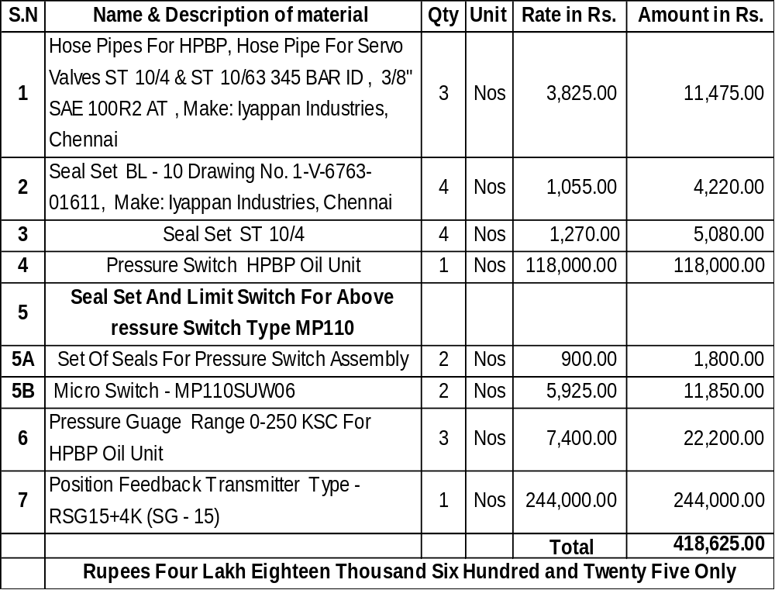

TERMS & CONDITIONS:
      - PRICES: The above prices are FOR Ex-works Delhi basis. The above prices shall remain firm in all respects during the currency of the delivery period, inclusive of any extended delivery period and shall not vary on any account, what so ever.
      - PACKING & FORWARDING CHARGES: Nil.
      - Freight Charges: Extra@ 2%
      - GST: IGST Extra@18% or as applicable at the time of dispatch.
      - INSURANCE: The material must be sent duly insured against our Marine cum Transit Insurance Policy No.221100/21/2019/2 of M/s. Oriental Insurance Company Limited, Divisional Office-2 , ^{9th} Floor Vikas Deep Building,22-Station Road, Lucknow - 226019 (Valid from 03.06.2018 to 02.06.2019 both days inclusive) that should be informed the full details of the dispatches under registered cover under intimation to EE Central Stores Division-II, Parichha within 24 hours of dispatches of material so that transit risk may be covered properly.
      - DELIVERY: The material shall be supplied within 24 Weeks. The fifth day of dispatch of this letter would be deemed as the date of receipt of order from which the delivery period would be reckoned. The date of submission of Proforma Invoice shall be treated as date of readiness of material. Proforma invoice will not be accepted without the intimation of readiness of material. The material may be taken in lots on as and when required basis.
- PAYMENT: 100% payment against tax invoice. GST PI shall be submitted in advance only for preparation of payment. Material will be dispatched only after dispatch clearance from UPRVUNL and receiving of readiness of payment and will be paid to firm in form of RTGS/NEFT against delivery of material at store.
- INSPECTION: The material shall be inspected by the inspection committee at store, PTPP, Parichha however material may be inspected by the inspection committee at Firm’s at Firm’s works at Chennai before Dispatch of material if required. In case of any defective material shall be replaced by the supplier at free of cost.
- GUARANTEE/ WARRANTEE CERTIFICATE: Guarantee/ Warrantee certificate will be submitted on firm letter head confirming that the equipment will be guaranteed against all manufacturing defects for a period of 12 months from date of commissioning or 18 months from date of supply whichever is earlier.
- CONSIGNEE: The material shall be consigned and dispatched to Executive Engineer, Central Stores Division-II, PTPP, Parichha, Jhansi- 284305.
- SECURITY CLAUSE: Not applicable.
- LD CLAUSE/ PENALTY: Penalty at the rate of half percent (1/2%) per week subject to a maximum of 10% of the cost of un-delivered goods shall be levied for the delay in supplies beyond stipulated delivery period
- All correspondence here-after, in connection with supply / dispatch of material and settlement of bill, Road Permit etc. shall be made with the Consignee i.e. Executive Engineer Central Store Division-II ( ee.csd_2.parichha@uprvunl.org ), Parichha Thermal Power Project, Parichha (Jhansi). For quality assurance Para 8 & 9 of procurement policy vides O. M no. letter no. 168/UNL/Reforms/purchase reforms/2010-11, dated 30-31.7.2010 shall apply.
- This order shall be governed by the form ‘B’ of U.P.S.E.B. containing general conditions on contract for the Supply of Plant & Machinery. Nigam reserves the right to correct the typographical/ clerical or any other error in PO. If the Nigam suffers any loss to infringement of the conditions mentioned in the supply of order, the same will be recovered from any of the Firm’s pending bills in Nigam & PO may be cancelled at any stage without any prior intimation to Firm.
- In case of any dispute, Court of jurisdiction will be Jhansi District Court / Allahabad High Court.
- The order may be cancelled, if the material is not supplied within six months after the expiry of the delivery period and suitable action shall be taken as per rules.
- Kindly acknowledge the receipt of the supply order within a week of the receipt of this order, failing which you will be deemed to have accepted the terms and conditions of our order.
Thanking You,
Yours Sincerely,
Encl…………………….
(Dilip Kumar Jain)
Executive Engineer

No. 1060/CPD-I/PTPP/O-1/CF442 Date: 11.10.2018
Copy forwarded to the following for information and necessary action:
  - Superintending Engineer, O & MC-IV, C&IEC, PTPP, Parichha (Jhansi)
  - Dy. C. A.O. (Accounts), PTPP, Parichha (Jhansi).
  - Executive Engineer, Central Store Division-II, PTPP, Parichha (Jhansi) (In three copies )
  - Executive Engineer, C&ID-II, with reference to Req. no. 190/EPED-I/2X250MW/PTEP/R-1, dated 27.06.2018 for O&M, 2X250 MW
  - AE-I,CPD-I, PTPP, Parichha.
  - Case file of enquiry no. 442 /CPD-I/ PTPP/CF, dated 25.07.18.
  - M/s. Iyappan Engineering Industries Private Limited, 107/A, 5th Street, Sector-1, SIDCO Industrial Estate, Ambattur, Chennai-600098, India.

(Dilip Kumar Jain)
Executive Engineer

